
North Bengal International University

Lab Report: 05
Exp Name : A program to implement of 2D array for matrix input & output in c program .

Subject : Data Structure
Subject Code : CSE 0612-2131

Submitted By:
Name : Md. Tanvir Rahman Pranto
Dept : CSE
Roll : 0712340012101005
Semester : 2nd Year, 4th semester.

Submitted To:
Name : Saifur Rahman
Designation : Lecturer
Dept : CSE
Date :

Code:
#include <stdio.h>

int main() {
int r, c, i, j;

printf("Enter number of rows: ");
scanf("%d", &r);

printf("Enter number of columns: ");
scanf("%d", &c);

int matrix[r][c];

printf("Enter %d elements:", r * c);
for (i = 0; i < r; i++) {
for (j = 0; j < c; j++) {
scanf("%d", &matrix[i][j]);
}
}

printf("Matrix output:\n");
for (i = 0; i < r; i++) {
for (j = 0; j < c; j++) {
printf("%d ", matrix[i][j]);
}
printf("\n");
}

return 0;
}

Output:
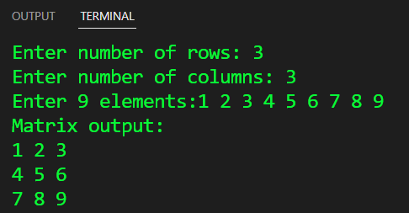

Conclusion: This This program takes user-defined rows (r) and columns (c) to create a flexible matrix. It collects input values, stores them in a 2D array, and displays the matrix in proper format. Simple, efficient, and adaptable

